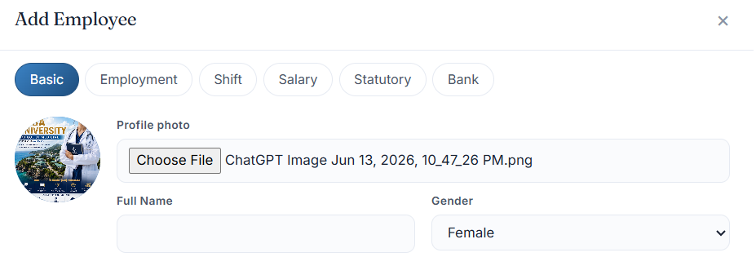
In employee master – profile photo – the image should fit properly.
Full name should be – first name & last name
Now while adding employee it the window suddenly closes and we need to start again.
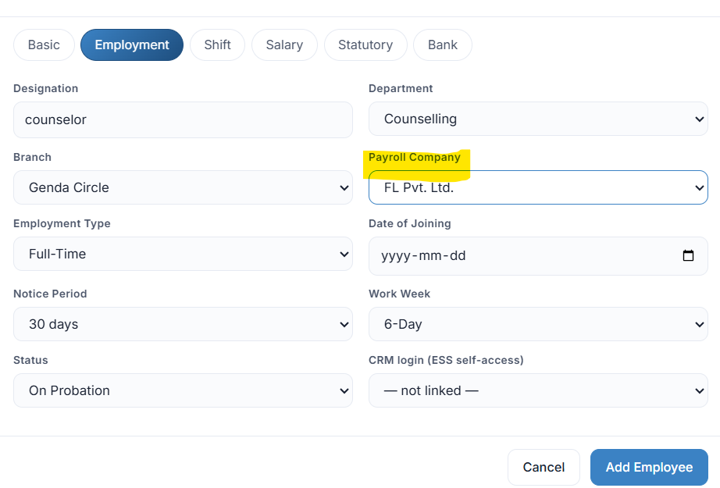
In payroll company full name should be visible and the data should be fetched from crm company masters
Making work week to working days a week throughout the system – and it should not be just 5 or 6 we should be able to select from drop down from 1 to 7, add this in the shift management master.
Crm login ( ess self access) – it shows not linked
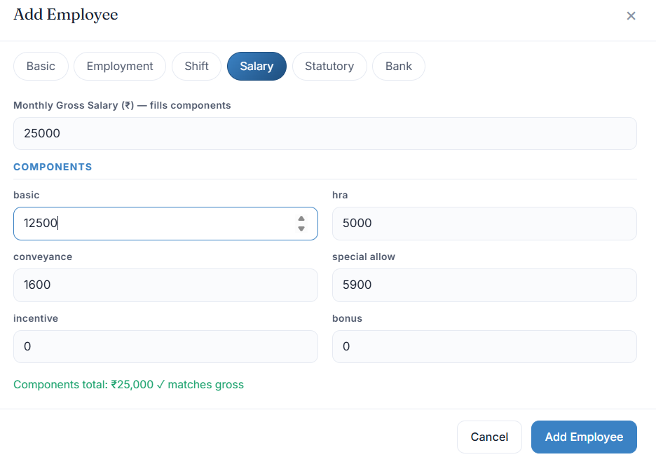
In salary section the currency should reflect as per the company we select. If its Indian Company then INR and if Canadian company then pay will be in CAD. The structure should also be as per Canada such as Vacation Pay (4% - manually we should set), EI, CPP, Tax.
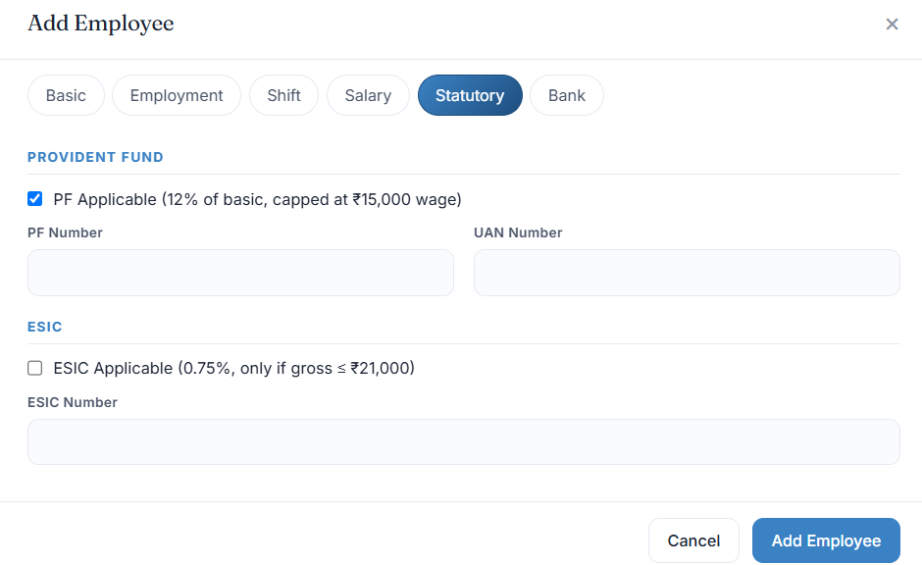
In the statutory section – need to add a check box first to confirm whether this employee has has PF account or not. If yes then PF is mandatory and if not then PF need to be confirmed YES/NO. Option to choose. Esic will also be optional after certain amount of salary limit. Under a basis salary it will be mandatory.
And need to add field of PT – professional tax – which will be 200 inr deduction as of today but may change anytime in future. So provision to change the amount.
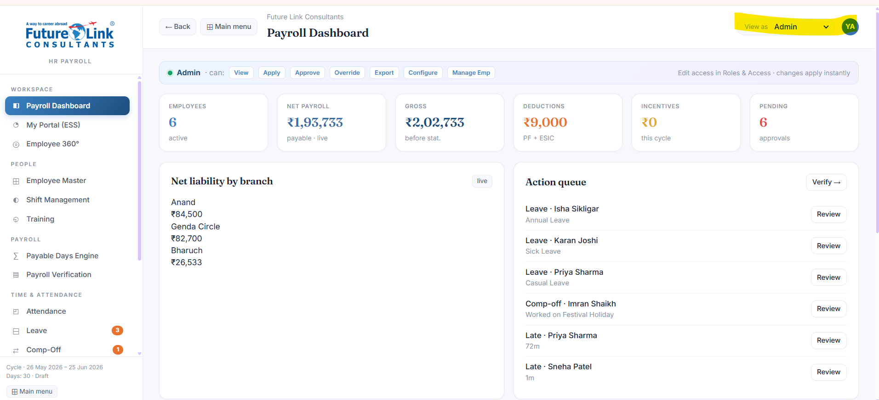

Give role based access only to the user. Currently most of the sections/details are visible to all types of users. Restrict it strictly to user role. Once this is done and fully tested and we confirm shift the complete admin user role and access section under HR Payrol where role will be defined and access will be given to each employee. Super admin will always override the admin role and super admin will be the company owner/ceo.

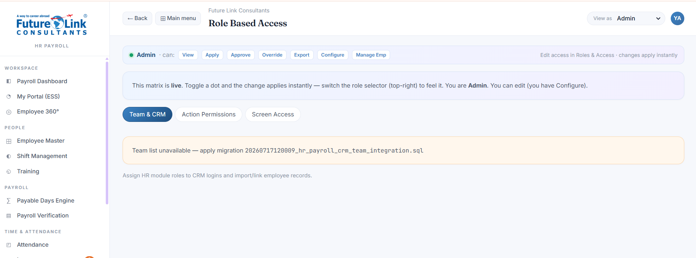

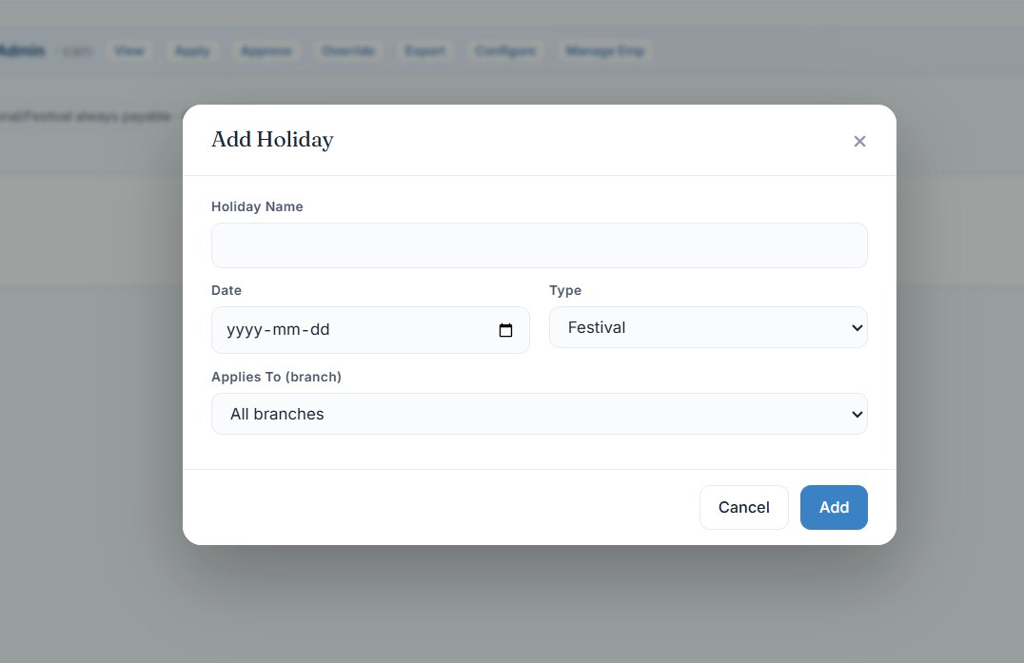
In the Add holiday master – need to add field to select to which shift is this application ( night/day/remote/hybrid/ part/full time, we can keep multiple selection option
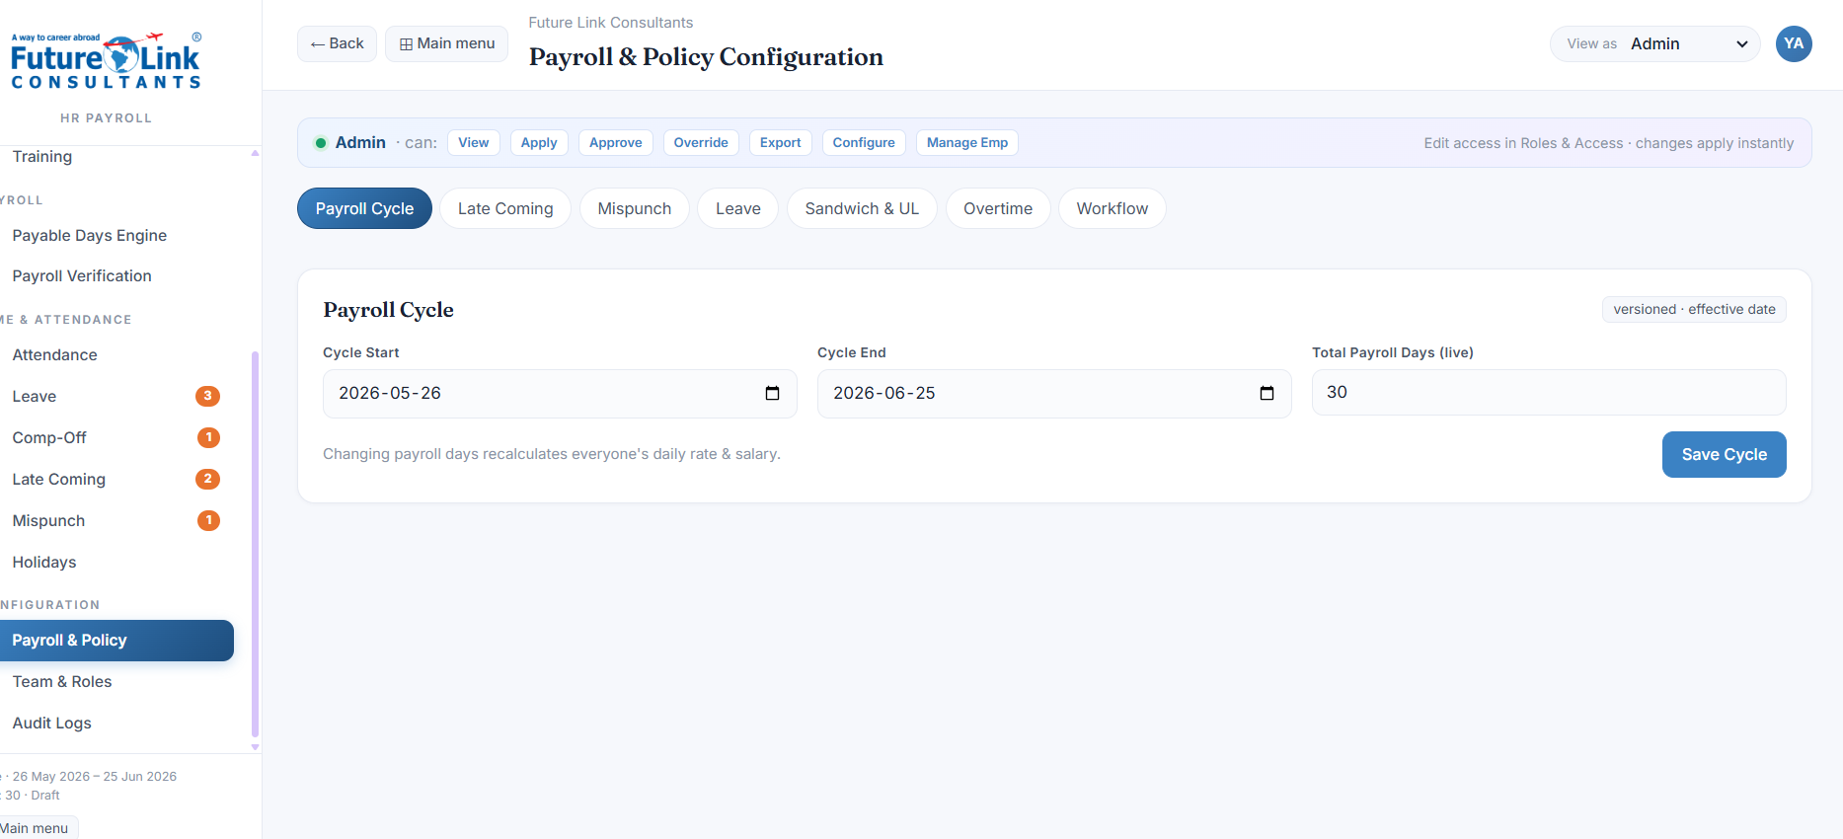

It should auto consider week off and holidays specific as well while doing salary calculation. Always calculate salary based on the days of the month 28, 29, 30, 31 and divide it into the salary amount. All public holidays declared by the company will be paid, all leaves approved to the limit of the allowed leaves will be paid and the leaves beyond allowed leaves even though approved but will be deducted. All leave and deduction policy rule will apply as defined earlier. Follow the same.

